Name | Emily Buckley | Date | Nov. 2, 2021
Delivery Season | F/W 2022 | Brand Label | Zara
Group Theme |  | Style Number | 6023
Size Classification | Women’s Woven | Size Range | XS-S-M-L-XL
Fabric Name | Denim | COO/ VENDOR | Tunisia/ Tunisia Woven’s
Fiber Content | 100% Cotton
Description | Women’s Oversized Button Front Top
Bill of Materials SHEET
Component Image | Component Name | Possible sources  Vendor | Size / Width /  Weight | Unit of Measure | Quantity
Fabrics
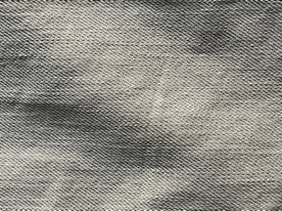 | Denim  100% Cotton | Tunisia Wovens | 2.75/60 | Yard | 2.25 yards
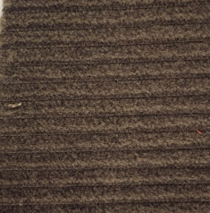 | Corduroy  100% Cotton | Tunisia Wovens | 4/60 | Yard | 2.25 yards
Trims (original) Type Color Size Unit Quantity
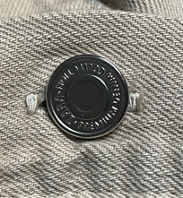 | Metal | Silver | 28L | Piece | 7
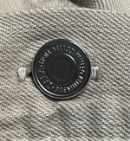 | Metal | Silver | 20L | Piece | 1
Thread
Allover | Core spun cotton polyester | Tan | .02/yard | Yard | 25 yards
Labels
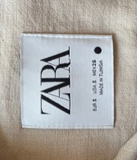 | Straight cut | White with black print | 2” x 2” | Piece | 1
Size /COO/Fiber Content/Care | Center fold | Black with white printed | 4 ½ “x 1” | Piece | 1

